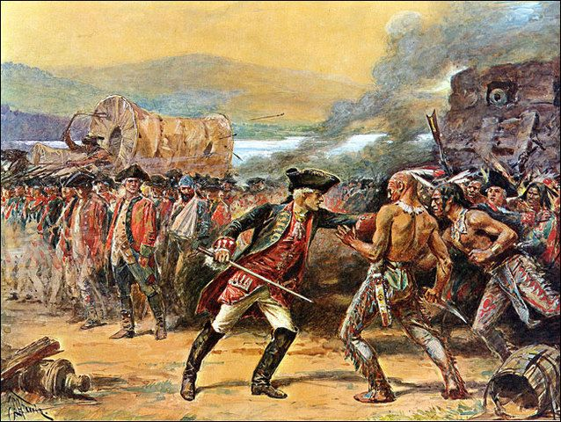
Conflict and Cooperation
Conflict and cooperation between the Native Americans, Europeans, and Africans influenced life in the new world. At first, Native Americans helped the colonists in Virginia and Plymouth to survive the first years by teaching them to plant crops such as tobacco and corn. But as more settlers came to the New World for land, the Native Americans began to resist them.

Native Americans and Colonists
Many wars were fought between the colonists and the Native Americans. With Robert LaSalle’s claim, the French had moved into the Ohio River Valley to claim this land for France. The English colonists and their mother country (England) then went to war with the French and their colonists in order to protect their claims. Many Native American tribes fought on the side of the French against the colonists and the British. This major conflict resulted in a series of four wars spanning over 74 years and fought on three different continents. The last of these series of wars is known as the French and Indian War.
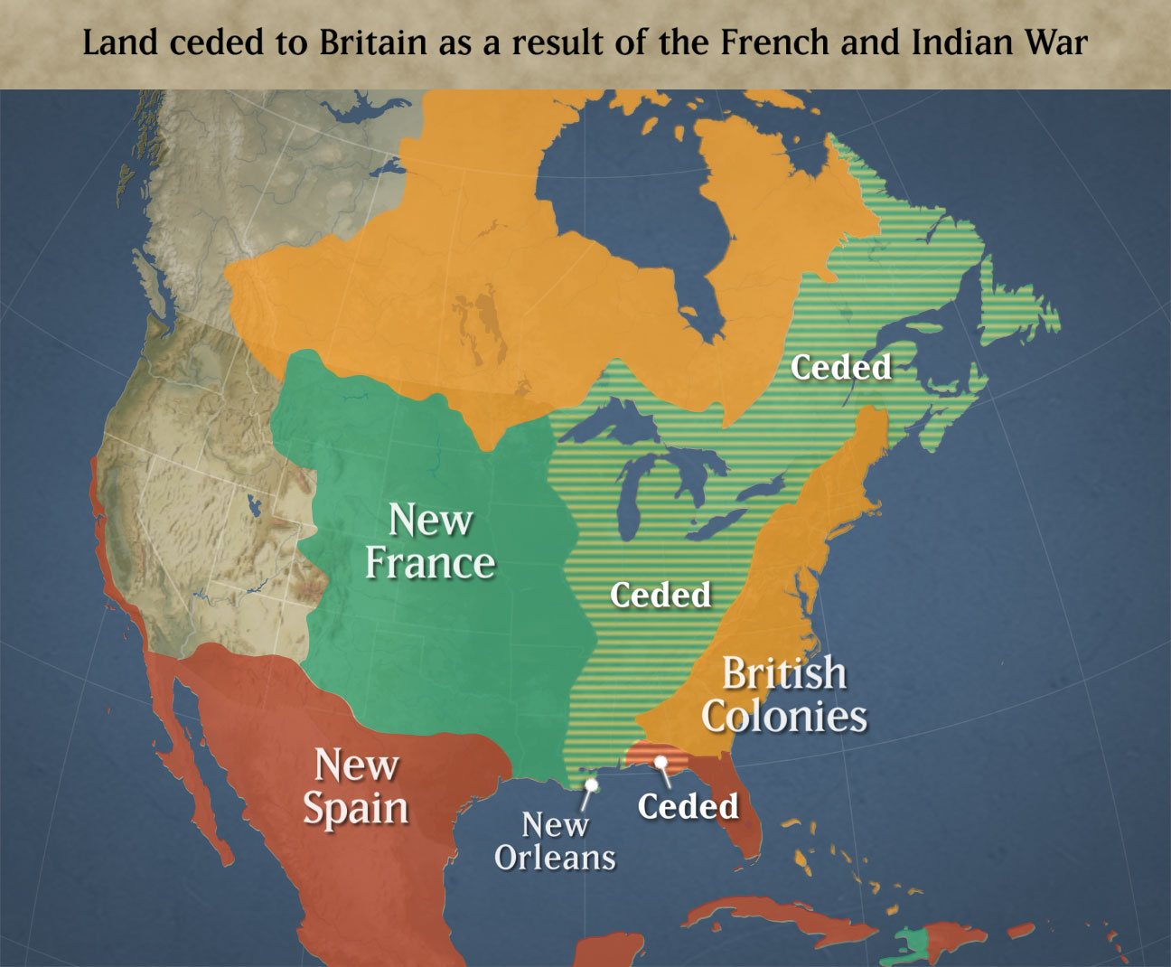
The French established good working relationships with the Native Americans because of their fur trading. Because few French settlers came to the New World and the ones who came did not take much land for families or settlement, the French did not bother the Native Americans as the English colonists did. Most Native American groups allied with the French. They hoped that a French victory (in the French and Indian War) would stop the English colonies from expanding into the Appalachian Mountains. However with the help of the Iroquois, Catawba and the Cherokee tribes, the British won the French and Indian War. This forced the French to lose control of their North American land claims. Many Native Americans then lost their long term trading partners and military allies with the French.

Slaves and Colonists
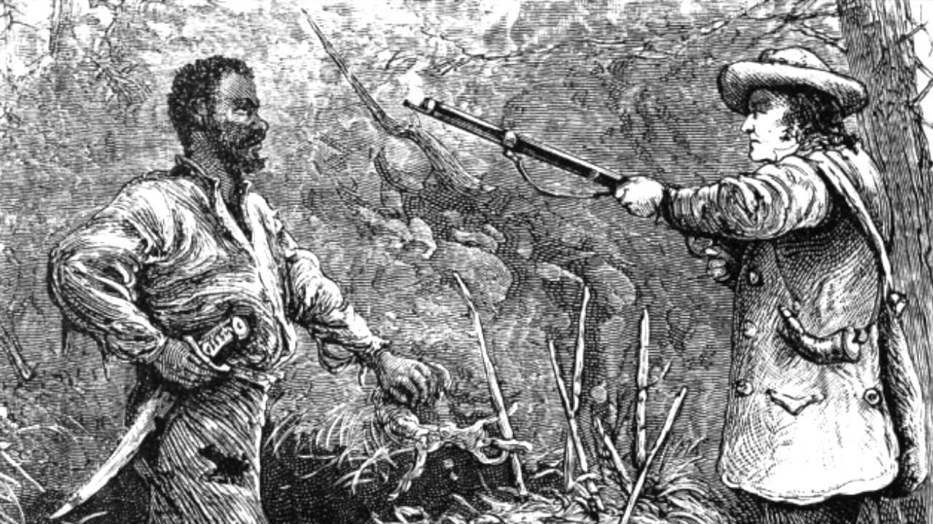
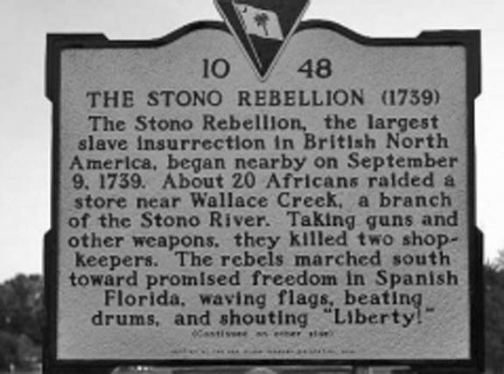
Plantation owners considered slaves to be their property and were often sold without warning. Slaves wanted to gain their freedom from plantation owners. Some slaves rebelled against the poor living conditions and abusive treatment of their slave owners. They would rebel by holding slave revolts. However, slave revolts like South Carolina’s Stono Rebellion were mostly unsuccessful. Some slaves were discovered before the revolt could be carried out. Others were quickly and brutally put down. Because slaves tried to rebel against their abusive owners, colonists then created slave codes. The slave codes were used to control and monitor the behavior of slaves in the colonies. The codes included rules such as limited slave education, purchases, and ability to sell goods. Slaves were also not allowed to travel without their master’s permission. Such revolts also made the slave owners and the colonists more fearful of the enslaved African population because the slave population already outnumbered the free population (colonists). In order prevent the slaves from continually revolting; some slave owners used violence and intimidation. Although slaves continued to resist their captivity through work slowdowns, faked illnesses, breaking tools, and running away; most were unsuccessful in escaping slavery. Some slaves did escape the bonds of slavery by heading North. Still some in the North were able to work to purchase their freedom and the freedom of other slaves. These free Africans were able to find work as artisans or apprentices in the New England colonies.

Slaves and Native Americans
There was some cooperation between slaves and Native Americans. For instance, runaway slaves in South Carolina fled to Florida where they joined Native American tribes. However, some Native Americans tribes adopted the practice of slavery themselves and enslaved the runaway slaves anyways.

Political impacts on settlement | Economic impacts on settlement | Geographical impacts on settlement | Social impacts on settlement

Cause | Effect
The French claimed land for their country.
 | Native Americans fought on both sides during the war.
The French lost the French and Indian War.

Native Americans cooperated with the French because… | Native Americans had conflict with the British because…
Why did the British win the French and Indian War? | Why do you think it is called the French and Indian War?

What were some examples of conflict between the slaves and colonists? | What were examples of cooperation between slaves and Native Americans?
What were examples of conflict between slaves and Native Americans? | Why do you think there was so much conflict between the colonists and the slaves?

