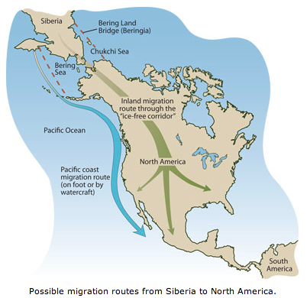
The Landbridge Theory
Groups of people migrated to North America for tens of thousands of years. At first it was mainly small groups of nomads that migrated. Nomads were people with no permanent settlements. Their movement was dependent on seasonal or other factors. Because these groups were small and continued to move about the continent, they often never had a sense of belonging to any larger society. It wasn’t until people began to settle that organized societies formed, creating hundreds of different languages, new technologies, and the beginnings of diverse cultures in the Americas.
According to the Land Bridge Theory, Native Americans migrated from Asia to North America across the land bridge during the Ice Age. During this time period, low temperatures caused the level of water in the ocean to drop. Because the frozen water became exposed, a long land bridge was created that connected Asia to North America. By following herds of animals, hunter-gatherer people may have crossed this land bridge from Asia into North America. Some of them may have then continued across North America and into South America.
Label the following on the map:
Asia, North America, and Landbridge

How did the spread of Native American populations
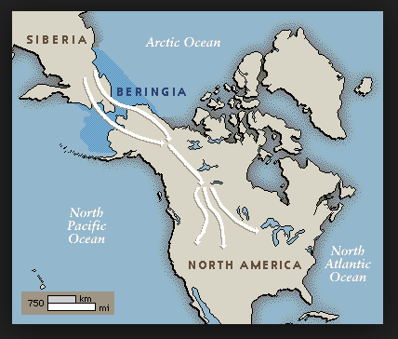
Influence the New World?

